CAREL – Confidential



**Gateway Middle End  
  
  
  
Test setup and use for  
2G models  
GTW000M2W0 / GTW000MGP0 / GTW000MGT0**

*Gateway Middle End*

rev. See revision table

DRAFT

Index

[Index 2](#_Toc42506034)

[Revisione 3](#_Toc42506035)

[1 Instructions 4](#_Toc42506036)

[1.1 Prerequisites 4](#_Toc42506037)

[1.1 Connect the HW 4](#_Toc42506038)

[1.2 Test SW on the PC 7](#_Toc42506039)

Revisione

|  |  |  |  |
| --- | --- | --- | --- |
| Rev. | Rev. date | Author | Note |
| *0.01* | *05/06/2020* | *A.Bilato* | 1° draft |
|  |  |  |  |
|  |  |  |  |
|  |  |  |  |
|  |  |  |  |
|  |  |  |  |
|  |  |  |  |
|  |  |  |  |
|  |  |  |  |
|  |  |  |  |
|  |  |  |  |
|  |  |  |  |
|  |  |  |  |

1. Instructions

Here below some instructions to modify the Gateway Middle End (GME) to be able to test it for the homologation.  
Scope of the modifications are to enable the device to be able to use the test FW   
supplied by the chips manufacturer, in short we need the direct access to the serial ports that control the chips.

* 1. Prerequisites

Inside the gateway, there are an Espressif ESP32 module and a Quectel M95 module.  
For the ESP32 module follow the instructions in the document <GME_Test_FW.docx>.  
For the M95 the test FW is already present inside the module, you need to install a SW on a PC to control easily the test functions (see below).   
The HW require a little modifications, you need a :

1. USB/TTL 3.3V serial converter
2. A push button
3. A 4K7 ohm resistor
   1. Connect the HW

You need to connect the USB/TTL 3.3V serial converter to the GME by some wire below the list of the points, and also bypass the power control of the M95 chip.  
Please refer to the electrical schematics (V.1.0.20) and to the below photos.

|  |  |  |  |
| --- | --- | --- | --- |
| **Purpose** | **Reference** | **Wire Color** | **Note** |
| USB/TTL TX data | Q5 | Yellow |  |
| USB/TTL RX data | Q201 | Blu |  |
| USB/TTL GND | J3 | Black | A useful point to connect the GND is the pin on J3 |
| Bypass power supply mosfet | Q105 C32  C15 | Red | Use the C32 and C15 pads to easy solder the wire |
| Kick power key pin | Q6 D13 | White | To do the pulse you need to connect the 3V3  you will found on D13 (A) through a 4K7 resistor and a push button and connected to the base of the transistor Q6 (B) |

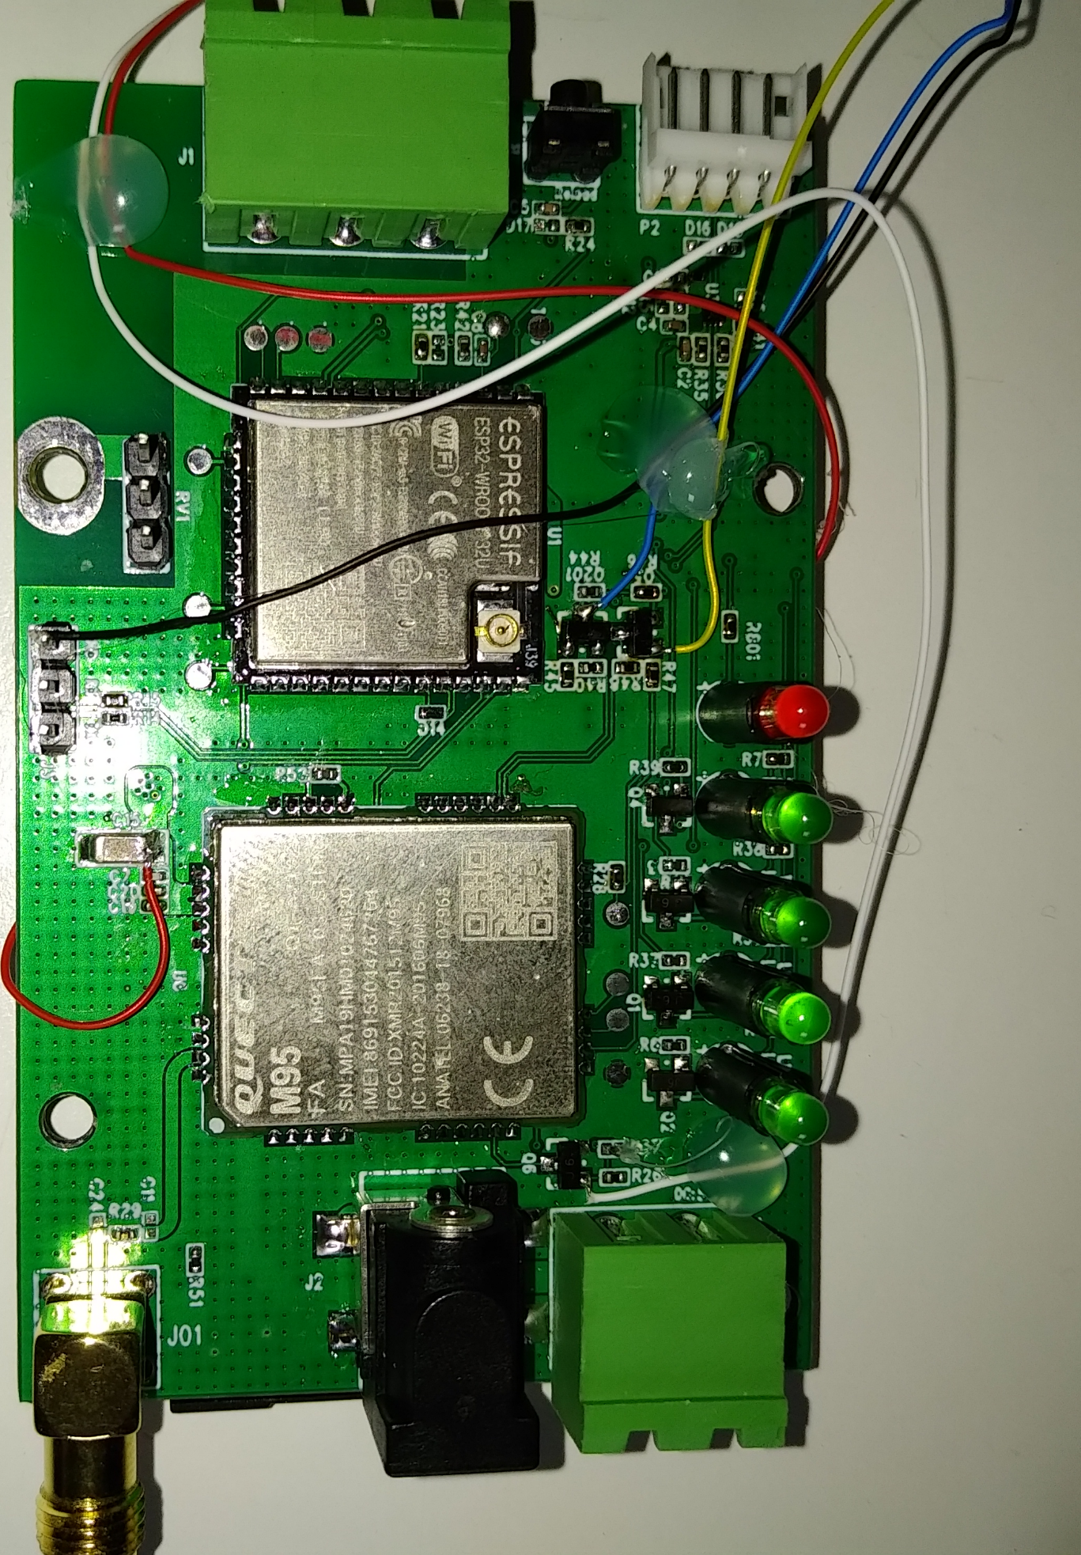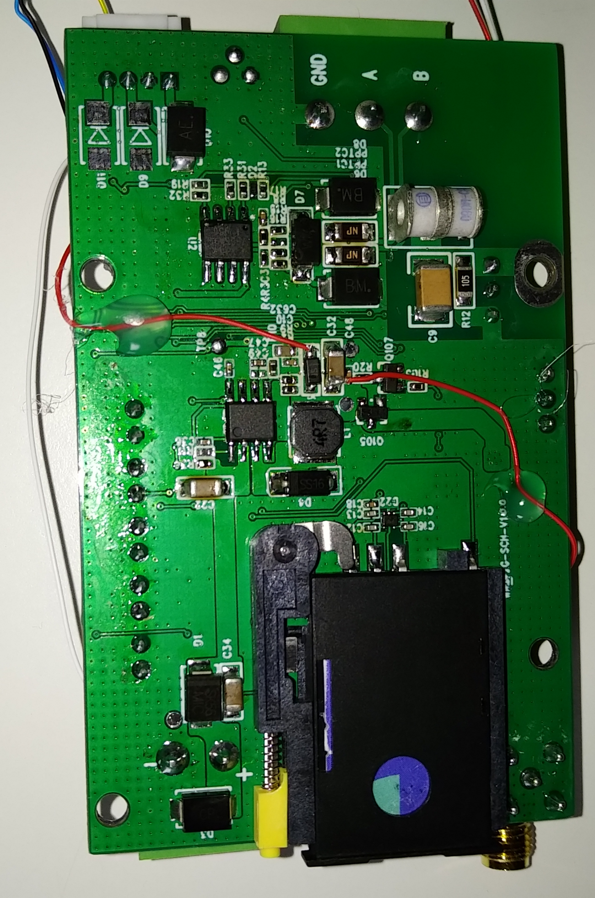

* 1. Test SW on the PC

To send the test command in an easy way (\*A) a Windows program is provided.  
The program use the .NET framework please install it if not already present on your PC.

To use it unzip the CAREL\_M95\_Test.zip in a suitable folder and launch the CAREL\_M95\_Test.exe program  
press the “Help” button to have more informations.

\*A Note: in case of trouble or if the homologation office use Linux for example is possible to send the AT test commands also via a terminal program with the following communications parameters 115200/8/N/1.